Lab 1 – Config OSPF and Investigate DRs and BDRs
Topology
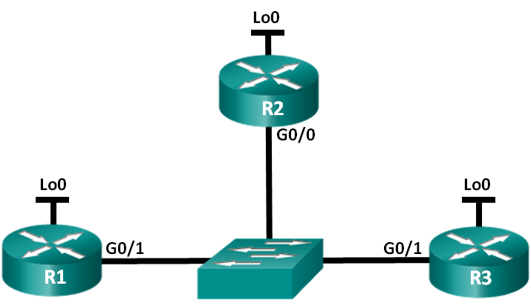
Addressing Table
Device | Interface | IP Address | Subnet Mask
R1-yourinitials | G0/1 | 192.168.10.1 | 255.255.255.0
 | Lo0 | 192.168.50.51 | 255.255.255.255
R2-yourinitials | G0/0 | 192.168.10.2 | 255.255.255.0
 | Lo0 | 192.168.50.52 | 255.255.255.255
R3-yourinitials | G0/1 | 192.168.10.3 | 255.255.255.0
 | Lo0 | 192.168.50.53 | 255.255.255.255
Objectives
Part 1: Build the Network and Configure Basic Device Settings
Part 2: Configure and Verify OSPFv2 on the DR, BDR, and DROther
Part 3: Configure OSPFv2 Interface Priority to Determine the DR and BDR
Background / Scenario
A multiaccess network is a network with more than two devices on the same shared media. Examples include Ethernet and Frame Relay. On multiaccess networks, OSPFv2 elects a Designated Router (DR) to be the collection and distribution point for link-state advertisements (LSAs) that are sent and received. A Backup Designated Router (BDR) is also elected in case the DR fails. All other routers become DROthers as this indicates a router that is neither the DR nor the BDR.
Because the DR acts as a focal point for OSPF routing protocol communication, the router chosen should be capable of supporting a heavier traffic load than other routers in the network. A router with a powerful CPU and adequate DRAM is typically the best choice for the DR.
In this lab, you will configure OSPFv2 on the DR, BDR, and DROther. You will then modify the priority of routers to control the outcome of the DR/BDR election process and ensure that the desired router becomes the DR.
Note: Make sure that the routers and switches have been erased and have no startup configurations. You should know how to quickly erase a router and a switch by now.
Required Resources
- 3 Routers (Cisco 1941 with Cisco IOS Release 15.2(4)M3 universal image or comparable)
- 1 Switch (Cisco 2960 with Cisco IOS Release 15.0(2) lanbasek9 image or comparable)
- Console cables to configure the Cisco IOS devices via the console ports
- Ethernet cables as shown in the topology
- Build the Network and Configure Basic Device Settings
In Part 1, you will set up the network topology and configure basic settings on the routers.
  - Cable the network as shown in the topology.
Attach the devices as shown in the topology diagram, and cable as necessary.
  - Initialize and reload the routers.
  - Configure basic settings for each router. Time = 15 minutes
    - Disable DNS lookup. Cmd is: No ip domain-name lookup
    - Configure device names as shown in the topology.
    - Assign Pass-12345 as the privileged EXEC password and vty passwords..
    - Assign cisco as the console password
    - Encrypt the plain text passwords.
    - Configure logging synchronous for the console line.
    - Configure the IP addresses listed in the Addressing Table for the interfaces.
    - Use the show ip interface brief command to verify that the IP addressing is correct and that the interfaces are active.
    - Copy the running configuration to the startup configuration.
- Configure and Verify OSPFv2 on the DR, BDR, and DROther
In Part 2, you will configure OSPFv2 on the DR, BDR, and DROther. The DR and BDR election process takes place as soon as the first router has its interface enabled on the multiaccess network. This can happen as the routers are powered-on or when the OSPF network command for that interface is configured. If a new router enters the network after the DR and BDR have already been elected, it does not become the DR or BDR, even if it has a higher OSPF interface priority or router ID than the current DR or BDR. Configure the OSPF process on the router with the highest router ID first to ensure that this router becomes the DR.

  - Configure OSPF on R3.
Configure the OSPF process on R3 (the router with the highest router ID) to ensure that this router becomes the DR.
    - Assign 1 as the process ID for the OSPF process. Configure the router to advertise the 192.168.10.0/24 network. Use an area ID of 0 for the OSPF area-id parameter in the network statement.
What is R3’s router ID?
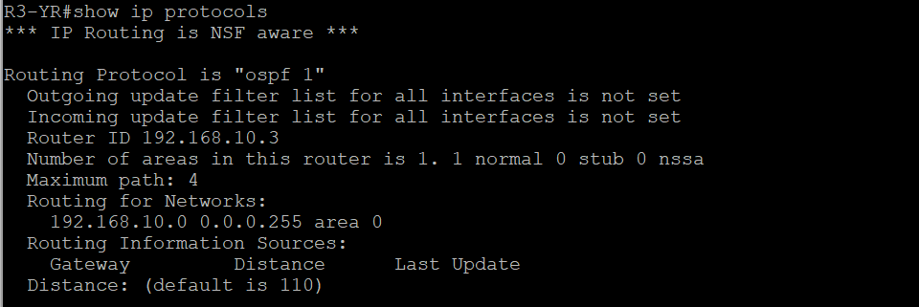Verify that OSPF has been configured and R3 is the DR.
What command would you use to verify that R3 is the DR?
Show ip ospf interface brief
  - Configure OSPF on R2.
Configure the OSPF process on R2 (the router with the second highest router ID) to ensure that this router becomes the BDR.
    - Assign 1 as the process ID for the OSPF process. Configure the router to advertise the 192.168.10.0/24 network. Use an area ID of 0 for the OSPF area-id parameter in the network statement.
    - Verify that the OSPF has been configured and that R2 is the BDR. Record the command used for verification.
      - 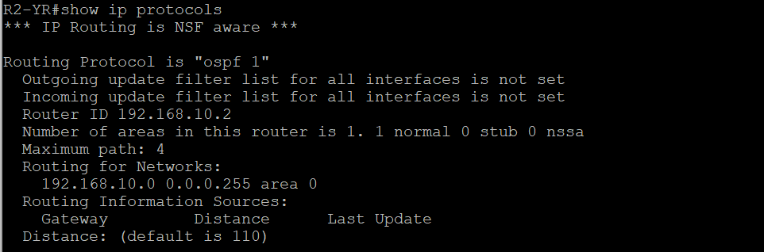Issue the show ip ospf neighbor command to view information about the other routers in the OSPF area. Paste the command and the output here:

According to the output – which route is DR? R1
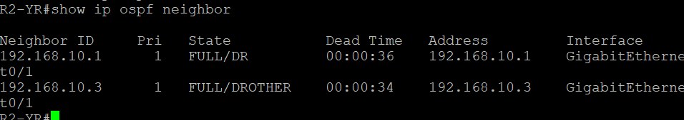
  - Configure OSPF on R1.
Configure the OSPF process on R1 (the router with the lowest router ID). This router will be designated as DROther instead of DR or BDR.
    - Assign 1 as the process ID for the OSPF process. Configure the router to advertise the 192.168.10.0/24 network. Use an area ID of 0 for the OSPF area-id parameter in the network statement.
    - Issue show ip ospf interface brief command to verify that OSPF has been configured and R1 is the DROther.. Paste the command and the output here:

Note – We configured first R3, then R2 than R1. After we finished the configuration we realized that the ethernet cable on R3 that connects to the switch was not working properly so we switched the cable.
After we did that the ospf DR was already configured to be another router in the election process and R3 ended up becoming Drother.
    - Issue the show ip ospf neighbor command to view information about the other routers in the OSPF area. Paste the command and the output here:
    - 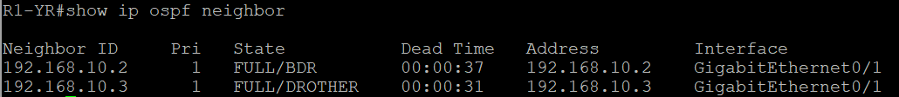

What priority are both the DR and BDR routers?
R1 is DR
R2 is BDR
R3 is DROTHER

- Configure OSPFv2 Interface Priority to Determine the DR and BDR
In Part 3, you will configure router interface priority to determine the DR/BDR election, reset the OSPFv2 process, and then verify that the DR and BDR routers have changed. OSPF interface priority overrides all other settings in determining which routers become the DR and BDR.
  - Configure R1 G0/1 with OSPF priority 255.
A value of 255 is the highest possible interface priority.
R1(config)# interface g0/1
R1(config-if)# ip ospf priority 255
R1(config-if)# end
  - Configure R3 G0/1 with OSPF priority 100.
R3(config)# interface g0/1
R3(config-if)# ip ospf priority 100
R3(config-if)# end
  - Configure R2 G0/0 with OSPF priority 0.
A priority of 0 causes the router to be ineligible to participate in an OSPF election and does not become a DR or BDR.
R2(config)# interface g0/0
R2(config-if)# ip ospf priority 0
R2(config-if)# end
  - Reset the OSPF process.
    - Issue the show ip ospf neighbor command to determine the DR and BDR.
    - Has the DR designation changed? YES Which router is the DR? R1
Has the BDR designation changed? YES Which router is the BDR? R3
What is the role of R2 now? DROTHER

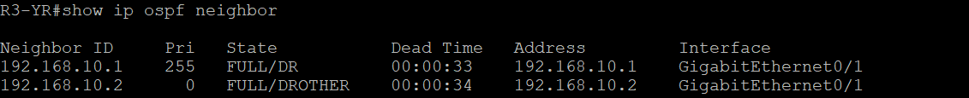
Explain what the ip ospf priority command does and its effect on your network.
It changes the election process of who becomes DR, BDR and DROTHER. Who has the highest priority becomes the DR and who has the lowest becomes DROTHER. The higher the number 0 – 255 the higher the priority.

Note: If the DR and BDR designations did not change, issue the clear ip ospf 1 process command on all of the routers to reset the OSPF processes and force a new election.
If the clear ip ospf process command does not reset the DR and BDR, issue the reload command on all routers after saving the running configuration to the startup configuration.

    - Issue the show ip ospf interface command on R1 and R3 to confirm the priority settings and DR/BDR status on the routers. Paste the commands and the output here:
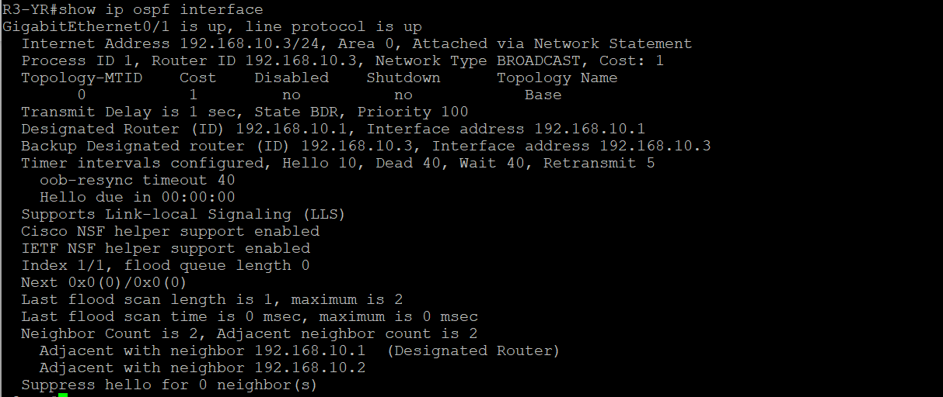
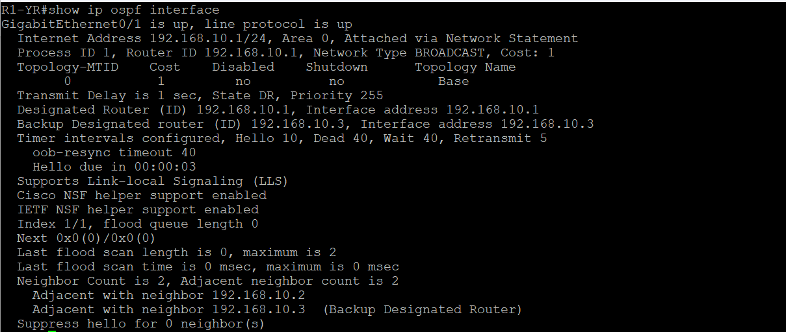

Which router is now the DR? R1
Which router is now the BDR? R3
Did the interface priority override the router ID in determining the DR/BDR? Yes.

Reflection
  - List the criteria used from highest to lowest for determining the DR on an OSPF network.
If no priority is set up first the DR will become the router with the highest IP address. In case the priority is set the DR will become the router with the highest priority 0-255 (the higher the number the higher the priority).
  - What is the significance of a 255 interface priority?
255 means that router will become the DR. Because this is the highest possible priority to be configured.

